**Challenge #3**

Country managers are our report readers, and they are responsible for key marketing decisions, forecasting product demand and recommending new products.

1. The report should be for the calendar year 2011 - 2013.
2. “Overview page”

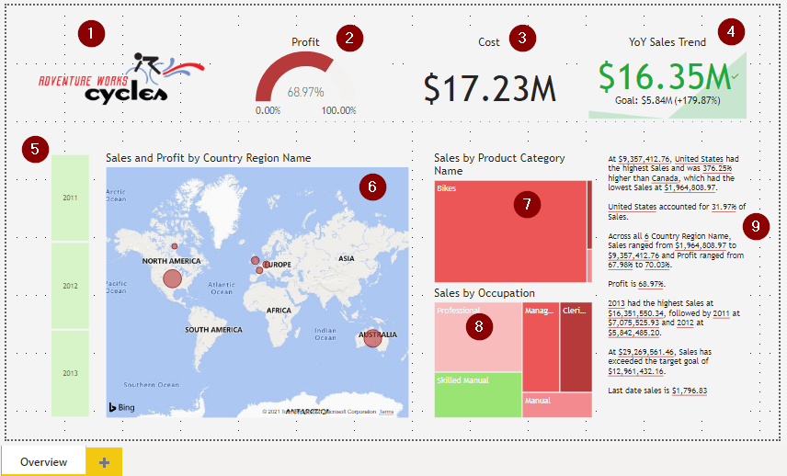

* 1. Adventure Works Cycles Logo
  2. Profit in Gauge  visual
  3. Cost in Card visual
  4. Year-to-year Sales in KPI visual
  5. Calendar Year in Slicer visual
  6. Sales and profit by country in Map  visual
  7. Sales by product category name in Treemap visual
  8. Sales by occupation in Treemap visual
  9. Summarize the trends and highlight the key points in Smart narrative visual
  10. Calendar Year slicer selection should filter all visuals except Year-to-year Sales visual

1. All visuals should follow standard corporate colors, visual formatting, and background colors to name a few. Apply a different theme or customize it

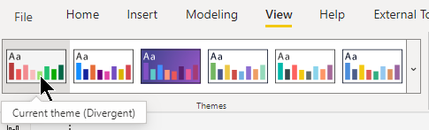

1. Insert a new page and rename it to “Geographic performance”

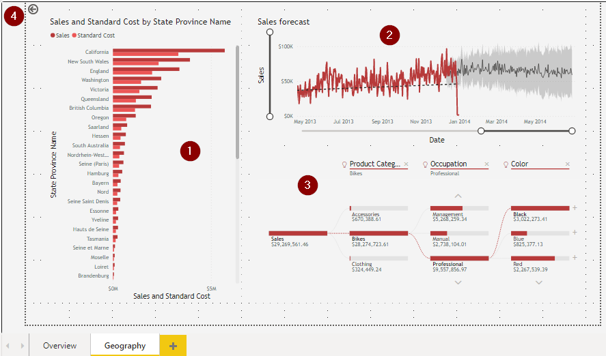

* 1. Sales and standard cost by state in Clustered bar  chart
  2. Sales forecast by Sales with trend line by  Line chart
  3. Split the sales amount by category name, occupation, color by Decomposition tree 
  4. Setup this page as the drill through page for Country[Country Region Name] field
  5. Let report readers personalize Sales and standard cost by state visual

1. Insert a new page and rename it to “Product category performance”

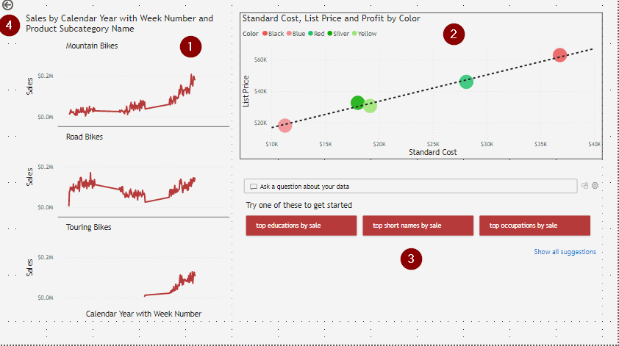

* 1. Sales by calendar year with week number and sub category name in small multiples by  Line chart
  2. Impact of Product[Standard Cost] on Product[List Price] by product color by  scatter chart visual
  3. Let the report readers ask questions about the data
  4. Setup this page as the drill through page for Product[Product Category Name] field